EXP.NO: 2 Write JavaScript Programme to validate the following fields of the HTML
Registration Page.

AIM:
To write JavaScript code to validate user input in a registration form. The validation will
ensure that the data entered by the user meets specific criteria for each field. This will help in maintaining data integrity and prevent invalid submissions.

ALGORITHM:
1. Input:
• The user fills in the following fields: First Name, Password, E-mail, Mobile
Number, Last Name, and Address.
2. Validation Steps:
1. Validate First Name:
o Check if the first name contains only alphabets.
o Ensure the length of the First Name is at least 6 characters.
o If any of these conditions fail, display an error message indicating the required
input.
2. Validate Password:
o Check if the password is at least 6 characters long.
o If it is less than 6 characters, display an error message.
3. Validate E-mail:
o Use a regular expression to check if the email follows the standard pattern:
name@domain.com.
o Ensure that the email contains no invalid characters and matches the required
pattern.
o If it doesn&#39;t match, display an error message indicating an invalid email
format.

4. Validate Mobile Number:
o Check if the mobile number contains exactly 10 digits.
o Ensure there are no alphabets or special characters.
o If the number is invalid, display an error message indicating the correct
format.
5. Validate Last Name:
o Ensure the Last Name field is not empty.
o If it is empty, display an error message.
6. Validate Address:
o Ensure the Address field is not empty.
o If it is empty, display an error message.

CODE:
Index.html:
<!DOCTYPE html>
<html lang="en">
<head>
<meta charset="UTF-8">
<title>Fitness & Health Tracker</title>
<link rel="stylesheet" href="style.css">
</head>

<body>

<!-- Navigation -->
<nav>
<h2>Fitness Tracker</h2>
<ul>
<li><a href="#" onclick="showPage('home')">Home</a></li>
<li><a href="#" onclick="showPage('form')">Application Form</a></li>
</ul>
</nav>

<!-- Home Page -->
<section id="home" class="page">
<div class="content">
<h1>Welcome to Online Fitness Tracker</h1>
<p>Track your health, calculate BMI and stay fit!</p>
</div>
</section>

<!-- Application Form Page -->
<section id="form" class="page">
<div class="form-container">

<h2>Health Application Form</h2>

<form id="fitnessForm">

<label>Name</label>
<input type="text" required>

<label>Age</label>
<input type="number" required>

<label>Height (cm)</label>
<input type="number" id="height" required>

<label>Weight (kg)</label>
<input type="number" id="weight" required>

<button type="button" onclick="calculateBMI()">Calculate BMI</button>

<p id="result"></p>

</form>

</div>
</section>

<script src="script.js"></script>
</body>
</html>

Style.css:
*{
margin:0;
padding:0;
box-sizing:border-box;
font-family:Arial;
}

body{
height:100vh;
}

/* Navigation */

nav{
display:flex;
justify-content:space-between;
align-items:center;
padding:15px 50px;
background:#222;
color:white;
}

nav ul{
display:flex;
list-style:none;
}

nav ul li{
margin-left:20px;
}

nav ul li a{
color:white;
text-decoration:none;
font-size:18px;
}

nav ul li a:hover{
color:orange;
}

/* Pages */

.page{
height:90vh;
display:none;
}

/* Home Page */

#home{
background:url("https://images.unsplash.com/photo-1517836357463-d25dfeac3438") no-repeat center/cover;
display:flex;
justify-content:center;
align-items:center;
text-align:center;
color:white;
}

.content{
background:rgba(0,0,0,0.6);
padding:40px;
border-radius:10px;
}

.content h1{
font-size:40px;
margin-bottom:10px;
}

/* Form Page */

#form{
background:url("https://images.unsplash.com/photo-1571019613914-85f342c55f7f") no-repeat center/cover;
display:flex;
justify-content:center;
align-items:center;
}

.form-container{
background:white;
padding:30px;
border-radius:10px;
width:300px;
}

form label{
display:block;
margin-top:10px;
}

form input{
width:100%;
padding:8px;
margin-top:5px;
}

button{
margin-top:15px;
padding:10px;
width:100%;
background:green;
color:white;
border:none;
cursor:pointer;
}

button:hover{
background:darkgreen;
}

#result{
margin-top:15px;
font-weight:bold;
}

#form{
background-color: #dff6ff;
display:flex;
justify-content:center;
align-items:center;
height:90vh;
}

Script.js:
function showPage(page){

document.getElementById("home").style.display="none";
document.getElementById("form").style.display="none";

document.getElementById(page).style.display="flex";

}

// Default page
showPage("home");

function calculateBMI(){

let height = document.getElementById("height").value/100;
let weight = document.getElementById("weight").value;

let bmi = weight/(height*height);

bmi = bmi.toFixed(2);

let result = "";

if(bmi < 18.5)
result = "Underweight";

else if(bmi < 25)
result = "Normal Weight";

else if(bmi < 30)
result = "Overweight";

else
result = "Obese";

document.getElementById("result").innerHTML =
"Your BMI is "+ bmi +" ("+ result +")";

}
OUTPUT:
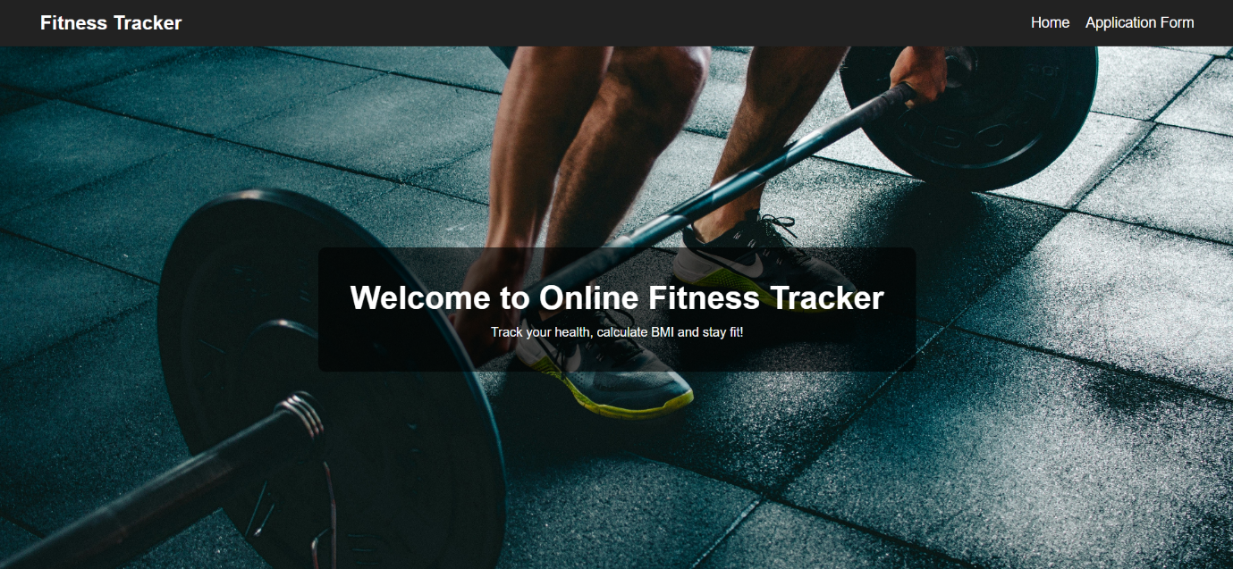

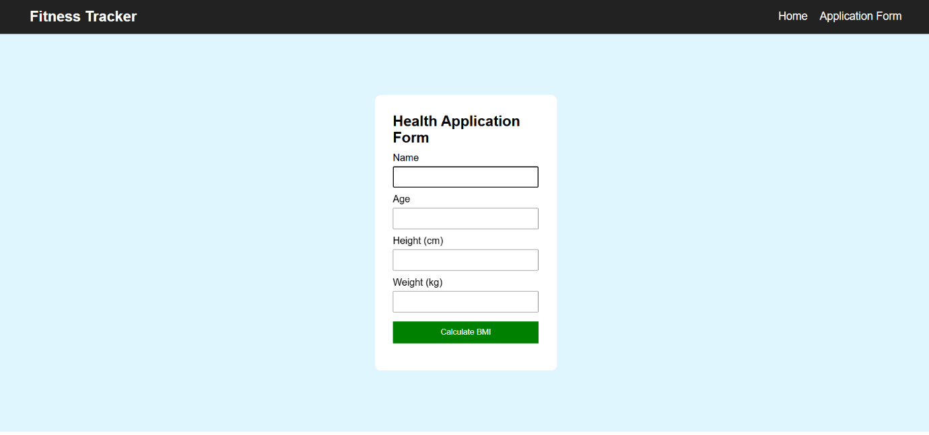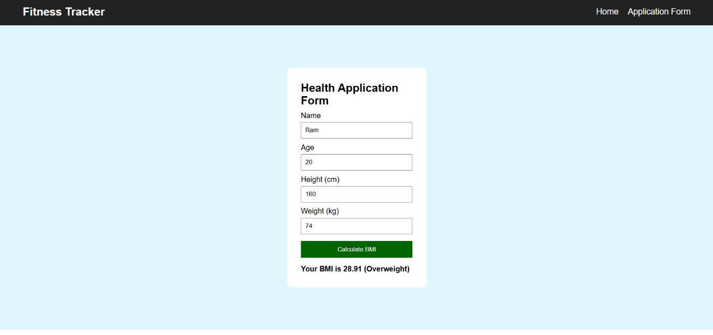
RESULT:
HTML page with Form is created and is validated using Javascript.

